Troubleshoot EtherCAT Configuration Mismatching Errors

Winmax requires each EtherCAT slave on the bus having a unique address. Actual address of each slave on the bus has to be same as the Winmax configured address. An error message will be displayed if Winmax detects a mismatch between its configuration and actual settings of slaves. This document intends to provide instructions to troubleshoot configuration mismatching errors.

- Slave Address
Each slave on the bus needs a unique address. SGDV, SD and EtherCAT RMB provide two rotary switches. These rotary switches can be used to setup slave address. Please use the following table to properly setup address of each slave on the bus.
Device Type | Starting Address | Ending Address
Yaskawa SD | 1 (0x01) | 31 (0x1F)
Yaskawa SGDV | 32 (0x20) | 63 (0x3F)
EtherCAT RMB | 64 (0x40) | 95 (0x5F)

Note: A slave needs to be power cycled if its address is changed and power is on.

- Order of Slaves
Winmax can automatically detect and generate the network configuration file (ENI file) based on actual connected slaves. Winmax doesn’t enforce the order of connected slaves. To avoid potential network connection issues, strongly recommend connecting slaves based on pre-defined network topology. Winmax CNC configuration parameters have details about each axis.
- Example 1: VMX42 (3 -axis with SD spindle)
The order of connected slaves should be:
X (Slave0) --> Y(Slave1) -->Z (Slave2) --> S(Slave3).
Axis | Slave Type | Address
X | SGDV | 32 (0x20)
Y | SGDV | 33 (0x21)
Z | SGDV | 34 (0x22)
S | SD | 1 (0x01)

- Example 2: VMX30U (5-axis with SD spindle)
The order of connected slaves should be:
X (Slave0) --> Y(Slave1) -->Z (Slave2) --> S(Slave3) --> A(Slave4) --> C(Slave5).
Axis | Slave Type | Address
X | SGDV | 32 (0x20)
Y | SGDV | 33 (0x21)
Z | SGDV | 34 (0x22)
S | SD | 1 (0x01)
A | SGDV | 35 (0x23)
C | SGDV | 36 (0x24)

- Example 3: VM10U (5-axis with A1000 spindle)
The order of connected slaves should be:
X (Slave0) --> Y(Slave1) -->Z (Slave2) --> A(Slave3) --> C(Slave4) --> RMB(Slave5).
Axis | Slave Type | Address
X | SGDV | 32 (0x20)
Y | SGDV | 33 (0x21)
Z | SGDV | 34 (0x22)
A | SGDV | 35 (0x23)
C | SGDV | 36 (0x24)
S | RMB | 64 (0x40) Channel 3

- Troubleshooting
Configuration mismatching error can be caused by many factors such as faulty cables, loose cable connections, incorrect cable connections (input/output ports), or incorrect actual addresses. During startup, Winmax collects connected slaves information and writes into a logging file. The logging file "ecmasterxx.log" is located under the folder "D:\Hurco\Winmax\Ouptfiles\EcatDCM\". It can be used for diagnosing configuration mismatching error. By default, EtherCAT logging setting is configured as "Startup". In case the logging file is empty or does not exist, please enable "Startup" logging via Winmax CNC configuration parameters and reboot.

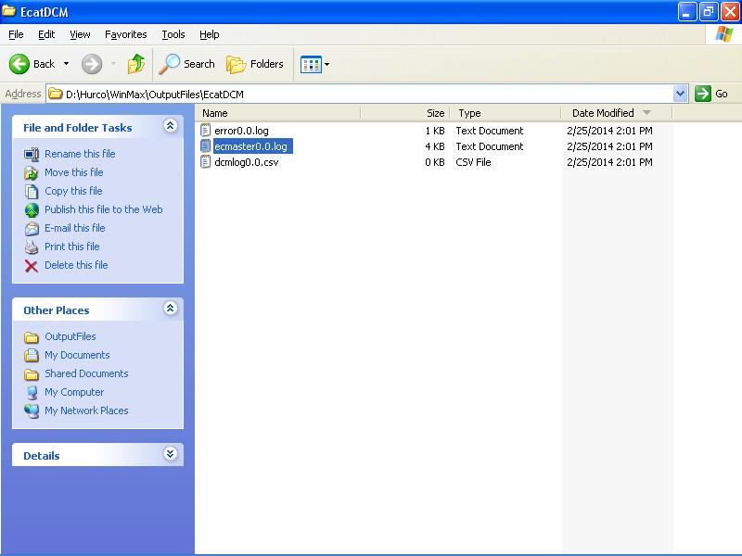
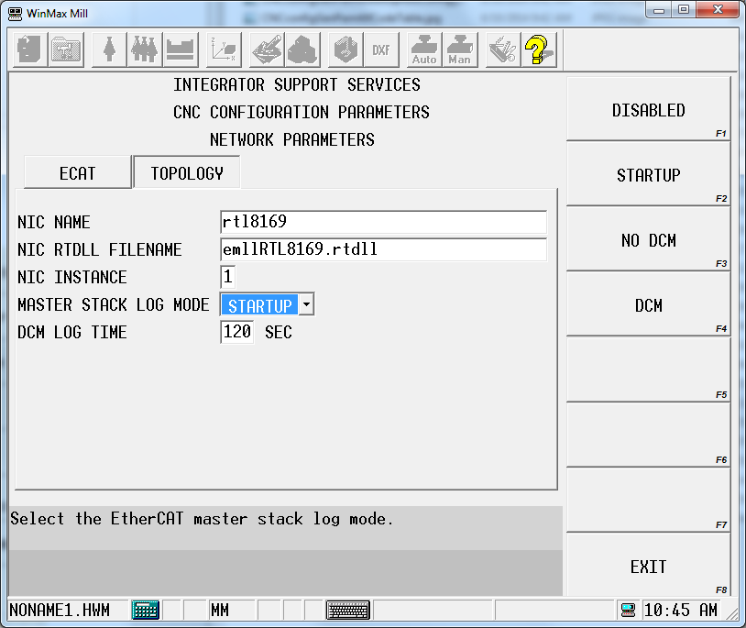
Figure 1: For machines before the i5 Card Rack and v10.1.70
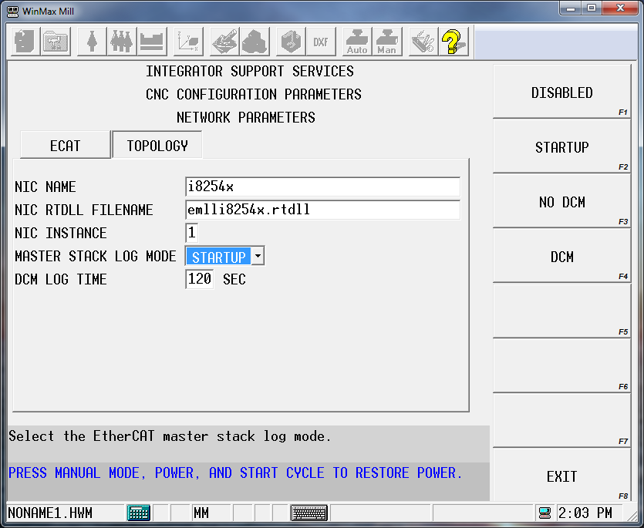
Figure 2: For machines with i5 or i7 CPUs

1. Winmx Error Message -- Servo Slaves Configuration Error
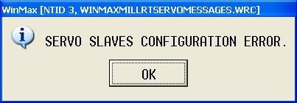
This error message indicates that at least one of slaves doesn't match Winmax configuration.
Solution: Check cables and connects. Verify Winmax configured address and actual address of each connected slave. Power cycle the machine.
Case 1: VMX30U (5-axis)
Open the latest logging file. Since Winmax automatically generates the network configuration file based on connected slaves so all of these three addresses (Station, Alias and Config station) are same and from the actual address set by two rotary switches on the drive. The file indicates that the address of second slave (Y-axis) was set to 35 (0x23) and it did not match Winmax configured address. The address in Winmax configuration of Y axis was configured to 33 (0x21) but the address on second slave (Y-axis) was set to 35 (0x23).
Solution: Correct second slave address to 33 (0x21). Power cycle the machine.
******************************************************************************
000348 : Number : 1
000348 : Vendor ID : 0x00000539 = Yaskawa Electric Corporation (Japan)
000348 : Product Code: 0x02200001 = SGDV-E1 CoE Drive
000348 : Revision : 0xFF050005 Serial Number: 0
000348 : ESC Type : Hilscher NetX 100/500 (0x80) Revision: 1 Build: 17
000348 : Bus AutoInc Address: -1 (0xffff)
000348 : Bus Station Address: 0035 (0x23)
000348 : Bus Alias Address : 0035 (0x23)
000348 : Config Station Address: 0035 (0x23)
000348 : PD IN Byte.Bit offset: 191.0 Size: 192 bits
000348 : PD OUT Byte.Bit offset: 105.0 Size: 80 bits
000348 : Port 0: Connected Port 1: Connected Port 2: Not_Conn. Port 3: Not_Conn.
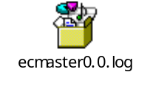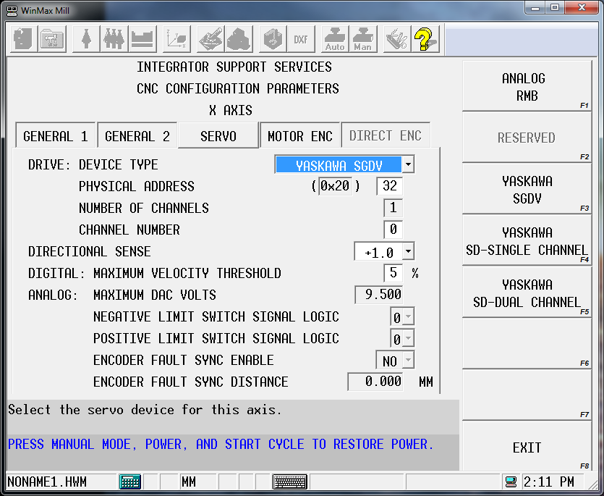
******************************************************************************
RMB Alarm | Resettable | 0x200E  control bit | Description | Solution
0xFF00 | NO | 0~4 | Encoder open/short detect of channel i | Verify Encoder Harness
0xFF01 | NO | 8~12 | A/B phase sequence detect of channel i | Verify Encoder Harness
0xFF02 | NO | N.A. | NODE ENABLE input | Verify J6 Harness
0xFF03 | NO | N.A. | Watchdog timer | Contact Engineering
0xFF04 | NO | N.A. | Out-of-bound condition of channel i  DAC zero calibration coefficient
0xFF05 | NO | 13 | EEPROM error detect | Contact Engineering
0xFF06 | NO | 14 | FPGA error detect | Contact Engineering
0xFF07 | NO | 5 | Cable broken detect | Verify all Harnesses are seated

